**Arithmetic Logic Unit (ALU)**: Hardware that performs addition, subtraction, and usually logical operations such as AND and OR.



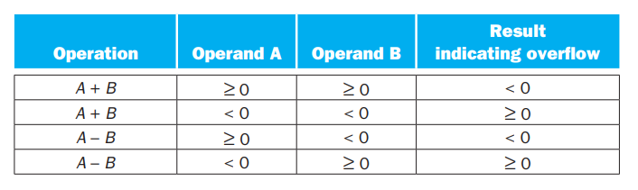

**Exception**: Also called interrupt on many computers. An unscheduled event that disrupts program execution; used to detect overflow.

**Interrupt**: An exception that comes from outside of the processor (Some architectures use the term interrupt for all exceptions).

MIPS includes a register called the **exception program counter (EPC)** to contain the address of the instruction that caused the exception.

**Saturation**: When a calculation overflows, the result is set to the largest positive number or most negative number, rather than a modulo calculation as in two’s complement arithmetic.



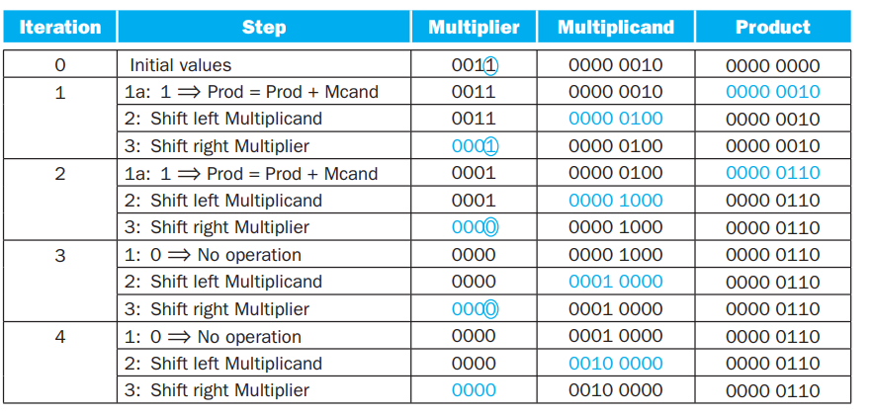



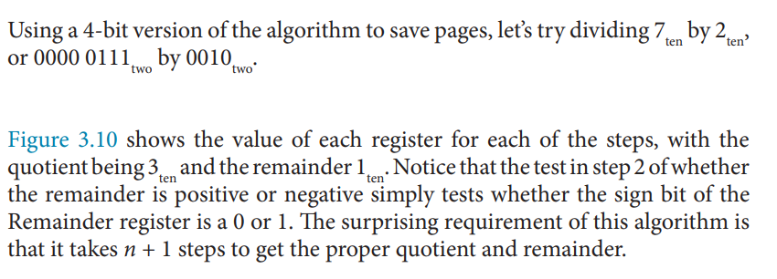

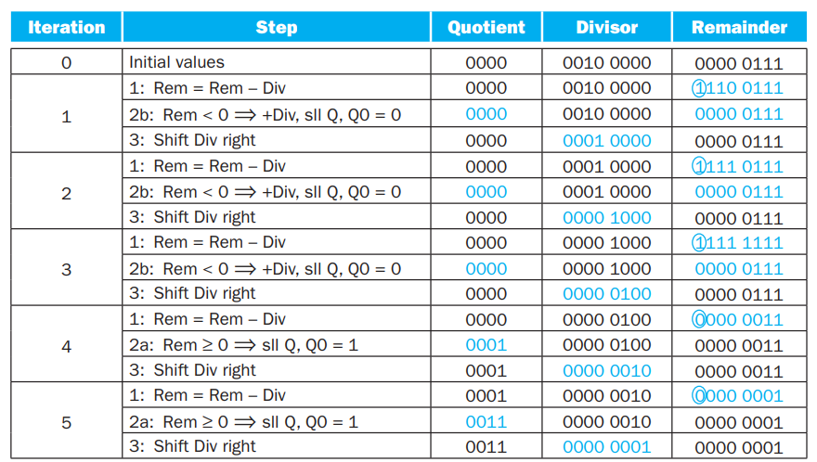



**Scientific Notation**: A notation that renders numbers with a single digit to the left of the decimal point.

**Normalized**: A number in floating-point notation that has no leading 0s.

**Floating Point**: Computer arithmetic that represents numbers in which the binary point is not fixed.

**Fraction**: The value, generally between 0 and 1, placed in the fraction field. The fraction is also called the mantissa.

**Exponent**: In the numerical representation system of floating-point arithmetic, the value that is placed in the exponent field.

A designer of a floating-point representation must find a compromise between the size of the fraction and the size of the exponent, because a fixed word size means you must take a bit from one to add a bit to the other. This **trade-off** is between precision and range: increasing the size of the fraction enhances the precision of the fraction, while increasing the size of the exponent increases the range of numbers that can be represented.

**Overflow** (Floating-point): A situation in which a positive exponent becomes too large to fit in the exponent field.

**Underflow** (Floating-point): A situation in which a negative exponent becomes too large to fit in the exponent field.

**Single precision**: A floating-point value represented in a single 32- bit word.

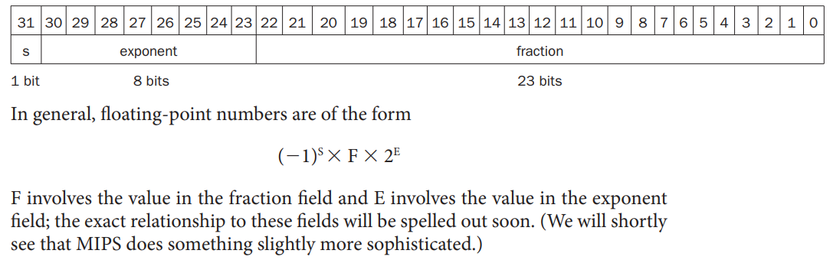

**Double precision**: A floating-point value represented in two 32-bit words.

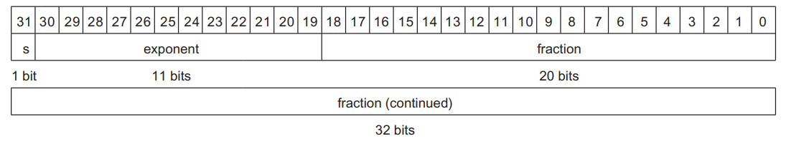

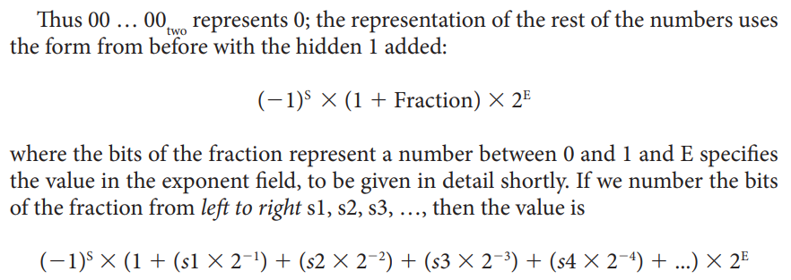

The desirable notation must therefore represent the most negative exponent as 00 … 00two and the most positive as 11 … 11two. Th is convention is called biased notation, with the bias being the number subtracted from the normal, unsigned representation to determine the real value.



Single Precision Bias: 127

Double Precision Bias: 1023

